AI-Assisted Documentation

2303A52460
M.Vivek
Batch-41
Task 1: Auto‑Generating Function Documentation
Prompt Used:
Generate Google-style docstrings for the following Python functions including description, parameters, return values and example usage.
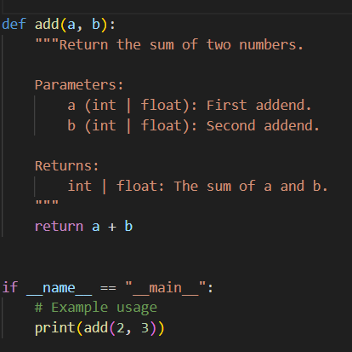
Output:
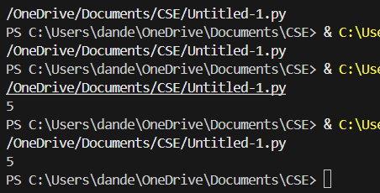
Example Code:
def add(a, b):
return a + b
def factorial(n):
if n == 0:
return 1
return n * factorial(n-1)
AI Generated Docstring Version:
def add(a, b):
"""Add two numbers.
Args:
a (int/float): First number.
b (int/float): Second number.
Returns:
int/float: Sum of a and b.
Example:
>>> add(2,3)
5
"""
return a + b
Explanation: AI automatically generated structured documentation improving readability and helping new developers understand function usage quickly.
Task 2: Enhancing Readability Through Inline Comments
Prompt Used:
Insert meaningful inline comments only where logic is complex.
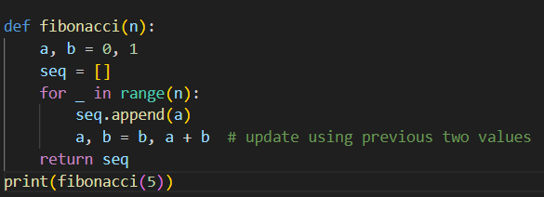
Example Code with Comments:
def fibonacci(n):
a, b = 0, 1
seq = []
for _ in range(n):
seq.append(a)
a, b = b, a + b # update using previous two values
return seq
Explanation: Comments explain algorithm reasoning without cluttering obvious syntax.
Task 3: Module-Level Documentation
Prompt Used:
Generate a module-level docstring describing purpose, dependencies, key functions and example usage.
Generated Module Docstring Example:
"""Utility Math Module
Provides helper math functions such as factorial and Fibonacci.
Dependencies:
None (standard Python only)
Functions:
add() - Adds two numbers.
factorial() - Computes factorial recursively.
Example:
import math_utils
print(math_utils.add(2,3))
"""
Explanation: Module docstrings help developers understand project structure immediately.
Task 4: Converting Comments to Docstrings
Prompt Used:
Convert explanatory comments inside functions into structured Google-style docstrings.
Converted Example:
def square(x):
"""Calculate square of a number.
Args:
x (int/float): Number to square.
Returns:
int/float: Square value.
"""
return x * x
Explanation: This reduces clutter and standardizes documentation format.
Task 5: Mini Documentation Generator Tool
Prompt Used:
Create Python utility that reads a .py file and inserts placeholder docstrings for functions and classes.
Sample Script:
import ast
def generate_docs(file):
with open(file) as f:
tree = ast.parse(f.read())
for node in ast.walk(tree):
if isinstance(node, ast.FunctionDef):
print(f"Function {node.name} needs docstring")
Explanation: Demonstrates automation of documentation scaffolding using AI-assisted coding.
Conclusion:
AI tools significantly improve documentation quality, reduce manual effort, and enhance code readability in real-world projects.

